**front porch news**

**July 2021**

### mature couple moving

## HOMEOWNERS ARE STAYING LONGER...

A decade ago, I could expect homeowners to move every 5 to 7 years. Today it's 8 to 10 years. That's one reason for the tight housing market. When an owner finally does decide to sell, the longer they've been in the house, the harder it can be for them to see their home as a commodity.

**One side effect of a long residency is lack of price perception**. You may attach more (or less) value to your home than the market will bear. Rather than ‘going by our guts' in pricing your home, we can interpret market data together to find the right price to get the highest offers.

**After 10+ years, you could be “house blind” to your own furnishings,** unaware of what helps or hinders the value of your home at first sight. I’ll help you prioritize what needs to be done.

**There’s more to do.** I understand you need time and help with resources to prepare your home and get moved. **You don't have to do it alone.** I've got a long list of service providers and will refer you to the right people, some of whom will take payment after selling.

**Leveling Off...**The trend towards rising prices is already leveling off in some areas. However, interest rates are still low and buyers are still buying, so ***now* might be your best chance to make the highest profit ever on your home**. Let me know you're interested in selling. Contact me for a no-obligation consultation. ***Robert Georgiou, 9259803248***

Call or text me for a referral to a plumber, handyman, carpet cleaner, house keeper, electrician, furnace cleaner, etc. I love referring the trusted pros I work with.

### 9259803248

**Robert Georgiou | 9259803248 | bob2sell@gmail.com**



### Who still needs to sell their home in 2021? Summer is a perfect time! Call me to get started.

## 9259803248

**Optional Images: Drag one image from below over the top of the flowers image (you can delete the flowers). When finished, delete this yellow instruction box and the extra image.**

## July Quiz Question

*What gives someone the power   
to walk through walls?*



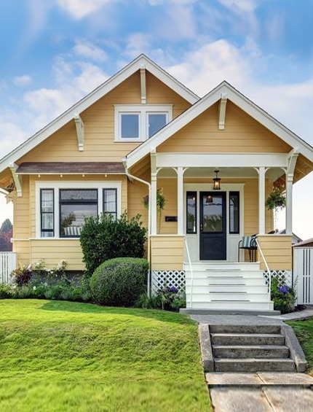



### ****What's the difference between a craftsman and a cottage?****

Craftsman houses feature exposed eaves, tapered porch columns, multi-paned windows, and ample wood and stonework. A cottage, by contrast, is any small home with quaint features, like built-ins and a rustic feel. A cottage can be any architectural style, including a Craftsman — but also a Cape Cod, farm house, Normandy, even converted garages.

### I KNOW PEOPLE…



### 

### new placeholder mugshotJuly_2021_Report QR Codewindmill stereogram

**To Insert Your Picture**

1. **RIGHT CLICK** on the placeholder image.
2. From the floating menu, choose **Change Picture**.
3. **Find and insert** your image from your computer.
4. **Resize and position** your image using your mouse.

See more about working with images in our tutorials: fastnewsletters.com/print-newsletter-tutorials

**Robert Georgiou**

**9259803248**

**bob2sell@gmail.com**

# WIN A $5 COFFEE CARD

To play, email me the answer to the question on **page 1**. Put the word **QUIZ** in the subject line. **bob2sell@gmail.com**

* **Last month’s question:** How many English words can you make by changing the last letter in the word June?
* **Last month's answer:** *One -* Junk*.*

Congrats to last month’s winner!

### Find the Hidden Windmill

##### Free Report:

#### How to get your vacation home to pay for itself

Perhaps you’ve dreamed   
of owning a seaside or  
mountain getaway, and you’ve thought, “Hey, what if I buy a home here, and then rent it to tourists like me to pay for it?” It doesn't always work out like that, but there are ways to make sure your second home isn't a drain on finances, and possibly pays for itself. Use your QR app to read now.

#### Slide this Alternative Article Over

You can slide this article over to cover the center panel **if you don’t need a label area**. You can also slide it over the top two articles if you prefer. (To slide it, click the edge until you see the **PLUS with ARROWS**. Then use your mouse to move it over.

**If you don’t need the article, click the edge, then DELETE on your keyboard.**

## Can you be on the deed of a home, if you're not on the mortgage?

Yes, you can be on the title or deed of the home as an owner without being on the mortgage. The person who has the mortgage is also an owner of the home. You are co-owners, but not co-borrowers.

There are important implications. The lender who provided the mortgage has a first position lien on the property. If something happens to the borrower, the mortgage company has the right to request payoff of the mortgage. The owner on title may now need to sell the house to satisfy the loan payoff, or be able to qualify to get a new loan to cover the value of the remaining loan amount.

This kind of problem occurs in a variety of situations. For instance, if parents put their adult children on the deed to a home as a method of handling inheritance, but the kids are not able to satisfy the loan requirements if the parents pass away or become incapacitated.

*Let me know if you have other questions or need help moving.*

*This newsletter is for entertainment purposes only. Credit is given to authors of articles that are reprinted when the original author is known. This information is solely for entertainment, and should not be substituted for medical, legal, financial or tax advice. This is not intended as a solicitation of listed property.*

##### Thank You Friends

My business depends on people like you. Special thanks this month to…

**If you know anyone making real estate plans in 2021,** please introduce us. I promise they’ll be grateful you did.

**front porch news**

Robert Georgiou

RE/MAX Accord

Danville \* Walnut Creek

01270522